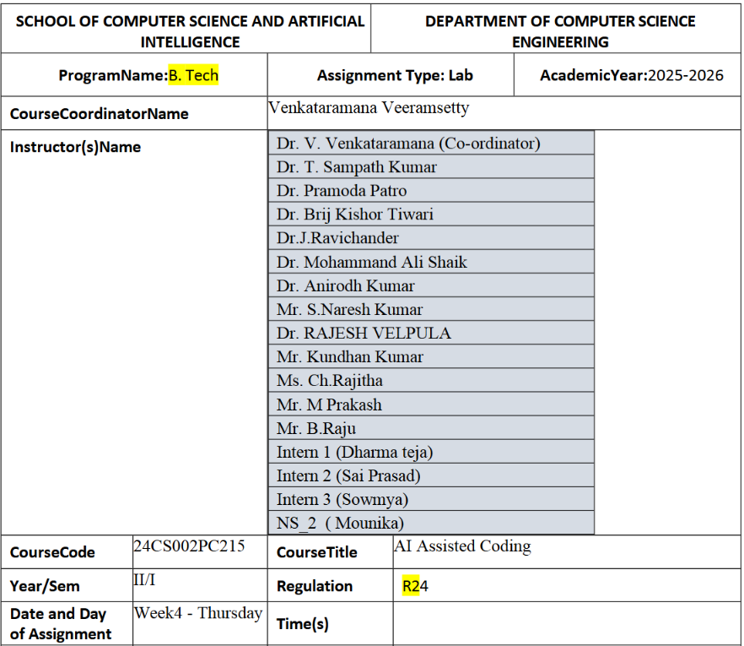
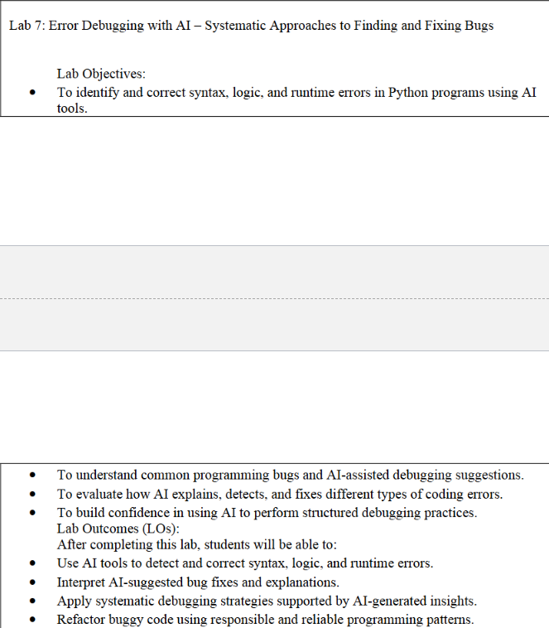
Task Description #1:
• Introduce a buggy Python function that calculates the factorial of a number using recursion.
Use Copilot or Cursor AI to detect and fix the logical or syntax errors.
Expected Outcome #1:
• Copilot or Cursor AI correctly identifies missing base condition or incorrect recursive call and
suggests a functional factorial implementation
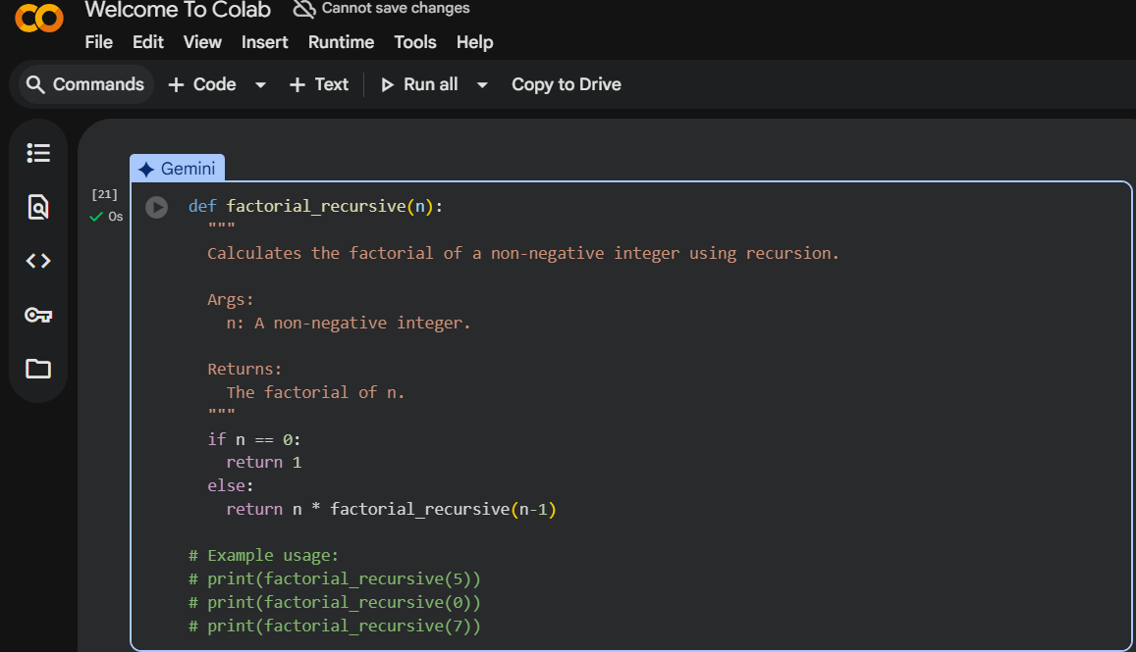
Task Description #2:
• Provide a list sorting function that fails due to a type error (e.g., sorting list with mixed
integers and strings). Prompt AI to detect the issue and fix the code for consistent sorting.
Expected Outcome #2:
• AI detects the type inconsistency and either filters or converts list elements, ensuring
successful sorting without a crash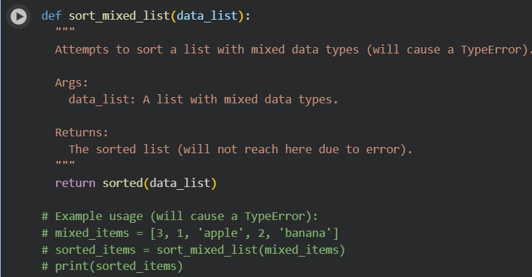
Task Description #3:
• Write a Python snippet for file handling that opens a file but forgets to close it. Ask Copilot or
Cursor AI to improve it using the best practice (e.g., with open() block).
Expected Outcome #3:
• AI refactors the code to use a context manager, preventing resource leakage and runtime
warnings
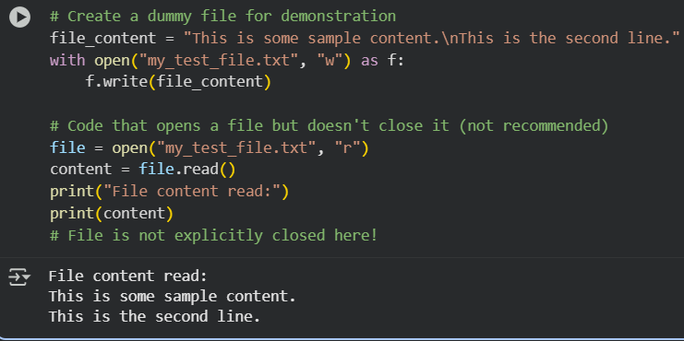
Task Description #4:
• Provide a piece of code with a ZeroDivisionError inside a loop. Ask AI to add error handling
using try-except and continue execution safely.
Expected Outcome #4:
• Copilot adds a try-except block around the risky operation, preventing crashes and printing a
meaningful error message
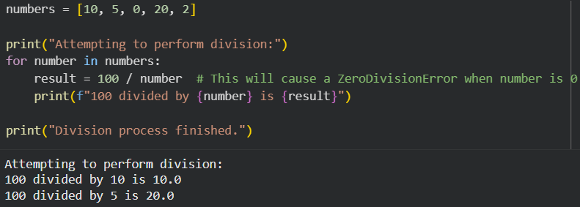
Task Description #5:
• Include a buggy class definition with incorrect __init__ parameters or attribute references. Ask
AI to analyze and correct the constructor and attribute usage.
Expected Outcome #5:
• Copilot identifies mismatched parameters or missing self references and rewrites the class with
accurate initialization and usage
